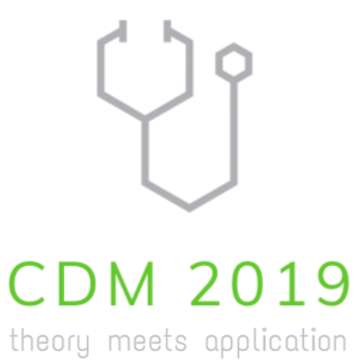

Registration Form

To register for the participation in CDM 2019 in Dortmund, Germany, 24-26 July, 2019, please fill in this form and mail it to

CDM2019@statistik.tu-dortmund.de

There is no fee for the workshop nor for the pre-workshop tutorial but participants are responsible for their own travel and accommodation. There is a limited amount of rooms available in the workshop hotel for 79€ resp. 99€ per night, which are reserved until 23 April. Hotel costs for speakers with accepted talks prior to 20 April are covered.

[ ] I have understood that I am responsible for my own accommodation. Email us if you would like us to help with booking a hotel.

Personal DetAils

First name(s): _______________________________________________________________
Last name: _______________________________________________________________
Address line 1: _______________________________________________________________
Address line 2: _______________________________________________________________
City: _______________________________________________________________
Postcode: _______________________________________________________________
Country: _______________________________________________________________
Email: _______________________________________________________________

Accompanying person(s)? [ ] No [ ] Yes
If yes, name of accompanying person(s): ___________________________________

Dietary or other Requirements we should be aware of: ____________________________
_________________________________________________________________________________

Pre-Workshop Tutorial

[ ] I would like to participate in the full-day Pre-Workshop Tutorial on 24 July, held on campus of TU Dortmund University.

Workshop

[ ] I would like to participate in the Workshop held on 25/26 July at the workshop hotel in Dortmund.

[ ] I would like to present an oral presentation. Depending on the number of submitted talks, the organizers will ask you for an abstract to arrive at a decision.

Preliminary Title: _____________________________________________________________

Date: ________________________

Signature: ________________________

www.statistik.tu-dortmund.de/CDM2019

